Final Year Project – I Proposal
ON
Pothole Detection using YOLOv11
BY:
Mohib malik 538
A final year project –I proposal submitted to ICS/IT. The University of Agriculture, Peshawar in partial fulfillment of the requirements for the degree of
BACHELOR OF SCIENCE IN COMPUTER SCIENCE
SESSION: 2022-2026



SUPERVISED BY:

INSTITUTE OF COMPUTER SCIENCE AND INFORMATION TECHNOLOGY
FACULTY OF MANAGEMENT AND COMPUTER SCIENCES
THE UNIVERSITY OF AGRICULTURE, PESHAWAR

Final Year Project – I Proposal
ON
Pothole Detection using YOLOv11
BY:
Mohib malik 538
A final year project –I proposal submitted to ICS/IT. The University of Agriculture, Peshawar in partial fulfillment of the requirements for the degree of
BACHELOR OF SCIENCE IN COMPUTER SCIENCE
SESSION: 2022-2026
Approved By:
_______________ Supervisor
Mr.
Lecturer ICS/IT
______________ Member
Mr.
Lecturer ICS/IT

_____________ FYP Coordinator
Mr. Gulzar Ahmed
Lecturer ICS/IT

____________ Director (ICS/IT)
Dr. Arshad Khan
Associate Professor ICS/IT

INSTITUTE OF COMPUTER SCIENCE AND INFORMATION TECHNOLOGY
FACULTY OF MANAGEMENT AND COMPUTER SCIENCES
THE UNIVERSITY OF AGRICULTURE, PESHAWAR
Table of Contents
- Introduction
- Background and Motivation
- Problem Statement
- Objectives
  - 4.1 Primary Objectives
  - 4.2 Secondary Objectives
- Scope of the Project
  - 5.1 In Scope
  - 5.2 Out of Scope
- Literature Review
- Methodology
  - 7.1 Data Collection
  - 7.2 Data Preprocessing and Augmentation
  - 7.3 Model Training
  - 7.4 Application Development
  - 7.5 Alert System
  - 7.6 Testing
  - 7.7 System Flowchart
- System Architecture
- Implementation Tools
- Expected Outcomes
- Project Timeline
  - 11.1 Timeline Table
  - 11.2 Gantt Chart

12.Conclusion
13.References

1. Introduction
Road infrastructure plays a critical role in the economic and social development of any country. Well-maintained roads ensure smooth transportation, reduce travel time, and improve overall safety for commuters. However, road surfaces are constantly subjected to environmental stress, heavy traffic loads, and weathering, which lead to the formation of various types of road damage. Among these, potholes are one of the most common and hazardous forms of road deterioration. Potholes occur when water seeps into cracks on the road surface, weakens the underlying layers, and causes sections of the pavement to break apart under vehicular pressure.
Potholes pose serious risks to both vehicles and road users. They can cause tire damage, suspension failures, loss of vehicle control, and even fatal accidents, especially during nighttime or in adverse weather conditions when visibility is limited. Beyond individual safety concerns, potholes lead to significant economic losses. Vehicle owners face increased repair costs, governments spend billions on emergency road repairs, and delays in logistics affect businesses and supply chains. According to global road safety reports, poor road conditions, including potholes, contribute to a substantial percentage of road accidents annually.
Traditionally, pothole detection and road maintenance rely on manual inspection conducted by road maintenance crews or field engineers. This method involves physically surveying roads, which is time-consuming, labor-intensive, and highly inefficient, particularly in large cities or remote areas. Manual inspection also suffers from delays in reporting, subjective assessment of damage severity, and incomplete coverage of road networks. As a result, many potholes remain undetected for extended periods, worsening over time and increasing repair costs.
Recent advancements in artificial intelligence, computer vision, and deep learning have opened new possibilities for automated road damage detection. Deep learning models, especially those from the YOLO (You Only Look Once) family, have revolutionized object detection by enabling real-time identification of objects in images and video streams. These models can analyze visual data, detect anomalies, and classify objects with high accuracy and speed. The latest iteration, YOLOv11, released by Ultralytics, offers enhanced performance, improved architecture, faster inference speed, and better accuracy compared to previous versions.
This project builds an intelligent pothole detection system using YOLOv11 that analyzes images or video from vehicle or surveillance cameras to detect potholes in real time and send alerts to authorities. It helps improve road safety, reduce inspection costs, speed up maintenance, and shows how modern deep learning can support smart city infrastructure.

2. Background and Motivation
Road maintenance is a constant challenge for governments and municipal authorities worldwide. The formation of potholes is influenced by multiple factors, including climate conditions, traffic density, construction quality, and drainage systems. In regions with frequent rainfall or extreme temperature fluctuations, potholes develop rapidly as water infiltrates pavement layers and causes structural damage. Heavy vehicles accelerate this deterioration by exerting significant pressure on weakened road surfaces.
Despite the availability of modern construction techniques and materials, maintaining extensive road networks remains costly and complex. Manual inspection methods are not only slow but also fail to provide comprehensive coverage. Inspectors may miss smaller potholes or fail to assess damage severity accurately, leading to delayed or inadequate repairs. Furthermore, in developing countries with limited resources, road maintenance budgets are often insufficient, resulting in neglected infrastructure and increased accident rates.
The motivation for this project stems from the urgent need to modernize road inspection processes using affordable and scalable technology. Deep learning-based pothole detection offers several advantages over traditional methods. First, it enables continuous monitoring through automated systems, reducing the need for human inspectors. Second, it provides objective and consistent assessments of road conditions, eliminating subjective judgment errors. Third, real-time detection allows for immediate reporting and faster response times, preventing minor damage from escalating into major hazards.
YOLOv11 represents a significant leap forward in object detection capabilities. Building on the success of earlier YOLO versions, YOLOv11 incorporates architectural improvements such as enhanced backbone networks, optimized anchor-free detection heads, and better feature fusion mechanisms. It achieves higher mean Average Precision (mAP) scores while maintaining real-time inference speeds, making it ideal for deployment in resource-constrained environments such as embedded systems or mobile devices. Its ability to detect small and irregularly shaped objects like potholes, even under challenging lighting conditions or partial occlusions, makes it particularly suitable for this application.
Automated pothole detection helps not only with safety but also with smarter maintenance planning. Authorities can use real-time data to prioritize repairs, manage budgets better, and lower long-term infrastructure costs. Citizens benefit through safer roads, fewer vehicle damages, and better overall living conditions. The system can also connect with smart city platforms to support data-driven decisions and predictive maintenance.
The project also shows how AI and deep learning can be used in civil engineering and infrastructure monitoring. By automating visual inspection tasks, it reduces dependence on manual surveys and demonstrates how computer vision can modernize public services through collaboration between computer science and engineering fields.
3. Problem Statement
Despite the critical importance of road maintenance, current methods for detecting potholes and road damage are insufficient, inefficient, and unsustainable. Manual inspection processes, which involve field engineers or road maintenance crews physically surveying roads, are labor-intensive, time-consuming, and costly. In large urban areas or rural regions with extensive road networks, it is nearly impossible to conduct frequent and comprehensive inspections. As a result, many potholes remain undetected for weeks or months, during which they worsen in severity and pose increasing risks to road users.
Manual inspection also suffers from inconsistency and subjectivity. Different inspectors may assess the same pothole differently, leading to discrepancies in damage classification and repair prioritization. Additionally, human inspectors can experience fatigue, limited visibility, or environmental distractions, which reduce the accuracy and reliability of assessments. In adverse weather conditions such as heavy rain, fog, or snow, manual inspections become dangerous and impractical, further delaying damage detection and repair.
Existing automated solutions, such as vibration-based sensors or laser scanning systems, have limitations. Vibration sensors detect surface irregularities indirectly by measuring vehicle suspension movements, but they lack the precision to identify specific pothole locations or assess damage severity accurately. Laser scanning systems, while more accurate, are expensive, require specialized equipment, and are not easily scalable for widespread deployment. Moreover, these systems often require post-processing and manual verification, which diminishes their real-time applicability.
There is a clear gap in the availability of affordable, accurate, and scalable pothole detection systems that can operate in real time using visual data. Such a system must be capable of processing video feeds from vehicle-mounted cameras or roadside surveillance systems, detecting potholes of varying sizes and shapes, and generating instant alerts for maintenance authorities. It should also be robust enough to handle diverse environmental conditions, including varying lighting, weather, and road surface textures.
This project addresses these challenges by developing a deep learning-based pothole detection system using YOLOv11. The system aims to automate the detection process, eliminate manual inspection inefficiencies, and provide real-time, accurate, and consistent results. By leveraging the latest advancements in computer vision, the project seeks to create a practical solution that can be deployed at scale, improving road safety, reducing maintenance costs, and contributing to smarter infrastructure management.

4. Objectives

4.1 Primary Objectives
- Build a deep learning model capable of detecting:
  - Potholes of various sizes and shapes
  - Different types of road damage (cracks, surface deterioration)
  - Road surface conditions in varying environments
- Analyze live video streams or recorded footage in real time for continuous road monitoring.
- Detect potholes instantly during operation with high precision and recall.
- Provide clear, visible, and immediate visual alerts

4.2 Secondary Objectives
- Develop a user-friendly desktop application (GUI) for interacting with the system.
- Support both video file input and live camera feed input for flexible deployment.
- Generate automatic logs and reports for each detected pothole, including location, timestamp, and severity level.
- Optimize the model's performance to achieve high speed and accuracy suitable for real-time processing on standard hardware.
- Test the system on diverse real-world datasets to ensure robustness and generalization across different road conditions.

5. Scope of the Project

5.1 In Scope
- Pothole detection from images and video streams
- Real-time video processing for live monitoring
- Desktop GUI development for system interaction
- Visual alert generation for detected potholes
- Support for multiple input sources (images, video files, live cameras)
- Performance optimization for deployment on standard GPUs
- Dataset preparation, augmentation, and training

5.2 Out of Scope
- Detection of other road features such as traffic signs, vehicles, or pedestrians
- 3D reconstruction or depth estimation of potholes
- Integration with GPS or mapping systems for geolocation tracking
- Web-based or cloud deployment (focus remains on desktop application)
- Long-term tracking of pothole evolution over time

6. Literature Review
The problem of automated road damage detection has gained significant attention in recent years due to advancements in deep learning and computer vision. Early approaches relied on traditional image processing techniques such as edge detection, texture analysis, and thresholding. However, these methods were highly sensitive to lighting variations, road surface textures, and noise, resulting in poor generalization and high false positive rates.
The introduction of Convolutional Neural Networks (CNNs) revolutionized computer vision tasks, including object detection. Models such as R-CNN, Fast R-CNN, and Faster R-CNN demonstrated the ability to detect objects with high accuracy by combining region proposal networks with CNN-based feature extraction. However, these models were computationally expensive and unsuitable for real-time applications due to their two-stage detection pipeline.
The YOLO family of models addressed these limitations by introducing single-stage, anchor-based object detection. YOLOv1, introduced by Redmon et al. in 2016, unified object detection into a single regression problem, enabling real-time inference. Subsequent versions, including YOLOv3, YOLOv4, and YOLOv5, improved accuracy, speed, and robustness through architectural enhancements such as multi-scale detection, CSPDarknet backbones, and advanced data augmentation techniques.
YOLOv8, released by Ultralytics, introduced an anchor-free detection head, improved loss functions, and better training workflows. It achieved state-of-the-art performance on benchmark datasets such as COCO and Pascal VOC while maintaining real-time inference speeds. YOLOv8 became widely adopted for various object detection tasks, including defect detection, medical imaging, and autonomous driving.
YOLOv11, the latest iteration, builds upon YOLOv8 with further architectural refinements, optimized inference pipelines, and enhanced support for edge deployment. It offers improved accuracy for small object detection, faster training convergence, and better generalization across diverse datasets. These features make YOLOv11 particularly suitable for pothole detection, where objects vary in size, shape, and appearance.
Prior research on pothole detection using deep learning has shown promising results. Several studies have applied YOLO-based models to detect potholes from dashcam footage, achieving high accuracy rates. However, many of these systems lack practical interfaces, real-time capabilities, or have been tested on limited datasets. This project addresses these gaps by using YOLOv11, training on diverse road damage datasets, and developing a fully functional desktop application for real-world deployment.

7. Methodology

7.1 Data Collection
High-quality and diverse datasets are essential for training robust deep learning models. For this project, the dataset will be sourced from Roboflow, a widely used platform for computer vision datasets and annotation tools. Roboflow provides ready-to-use datasets for pothole detection.
Pothole Detection Dataset
Link: https://universe.roboflow.com/pothole-detection-v2/pothole-detection-v2
Contains approximately 3,500 annotated images of potholes captured under various lighting and weather conditions.

7.2 Data Preprocessing and Augmentation
Roboflow will be used for data preprocessing, annotation verification, and augmentation. The preprocessing pipeline will include:
- Resizing: All images will be resized to 640x640 pixels to match YOLOv11 input requirements.
- Normalization: Pixel values will be normalized to improve training convergence.
- Annotation Format Conversion: Annotations will be converted to YOLO format (class, x_center, y_center, width, height).
Data augmentation techniques will be applied to improve model robustness and prevent overfitting:
- Horizontal Flip: Randomly flip images horizontally to simulate different viewing angles.
- Brightness Adjustment: Vary brightness levels to handle different lighting conditions.
- Rotation: Apply slight rotations (±10 degrees) to account for camera angle variations.
- Gaussian Noise: Add random noise to simulate low-quality camera feeds.
- Blur: Apply motion or Gaussian blur to mimic real-world camera shake.
The dataset will be split into:
- Training Set: 70% (2,800–3,500 images)
- Validation Set: 20% (800–1,000 images)
- Test Set: 10% (400–500 images)

7.3 Model Training
YOLOv11 will be trained using the prepared dataset. Training will be conducted on cloud-based GPU platforms such as Google Colab (Tesla T4 or A100 GPU) or Kaggle GPUs to ensure efficient training without requiring expensive local hardware.
Training Configuration:
- Model Variant: YOLOv11m or YOLOv11l (medium or large) for balanced accuracy and speed
- Input Image Size: 640x640 pixels
- Batch Size: 16 (adjustable based on GPU memory)
- Epochs: 100–150 epochs
- Optimizer: AdamW with learning rate scheduling
- Loss Function: Combined classification, objectness, and bounding box regression losses
- Data Augmentation: Mosaic, MixUp, HSV color space augmentation
Evaluation Metrics:
- mAP50 (mean Average Precision at IoU threshold 0.5)
- mAP50-95 (mean Average Precision across IoU thresholds 0.5 to 0.95)
- Precision: Proportion of correctly detected potholes among all detections
- Recall: Proportion of actual potholes correctly detected
- F1-Score: Harmonic mean of precision and recall
- Inference Speed: Frames per second (FPS) on test hardware
The goal is to achieve:
- mAP50 > 85%
- mAP50-95 > 70%
- Inference Speed > 30 FPS on a standard GPU

7.4 Application Development
A desktop application will be developed to provide an intuitive interface for pothole detection. The application will support both video file uploads and live camera feeds.
Application Features:
- Video Input Selection: Upload pre-recorded video files or connect to a live camera
- Real-Time Detection Display: Show video stream with bounding boxes around detected potholes
- Alert System: Display visual warnings (red boxes, text alerts) when potholes are detected
- Detection Logs: Automatically save detection results with timestamps and confidence scores
Technology Stack:
- Programming Language: Python 3.10+
- Deep Learning Framework: PyTorch, Ultralytics YOLOv11
- Computer Vision: OpenCV for video processing and frame extraction
- GUI Framework: Tkinter or PyQt5 for desktop interface
- Logging: CSV or JSON format for detection reports

7.5 Alert System
The alert system will provide instant notifications when potholes are detected. Alerts will include:
- Visual Alerts: Red bounding boxes around detected potholes with confidence scores
- Text Alerts: On-screen messages such as "Pothole Detected - Confidence: 92%"
- Log Generation: Automatic recording of detection events with timestamps, frame numbers, and coordinates
7.7 System Flowchart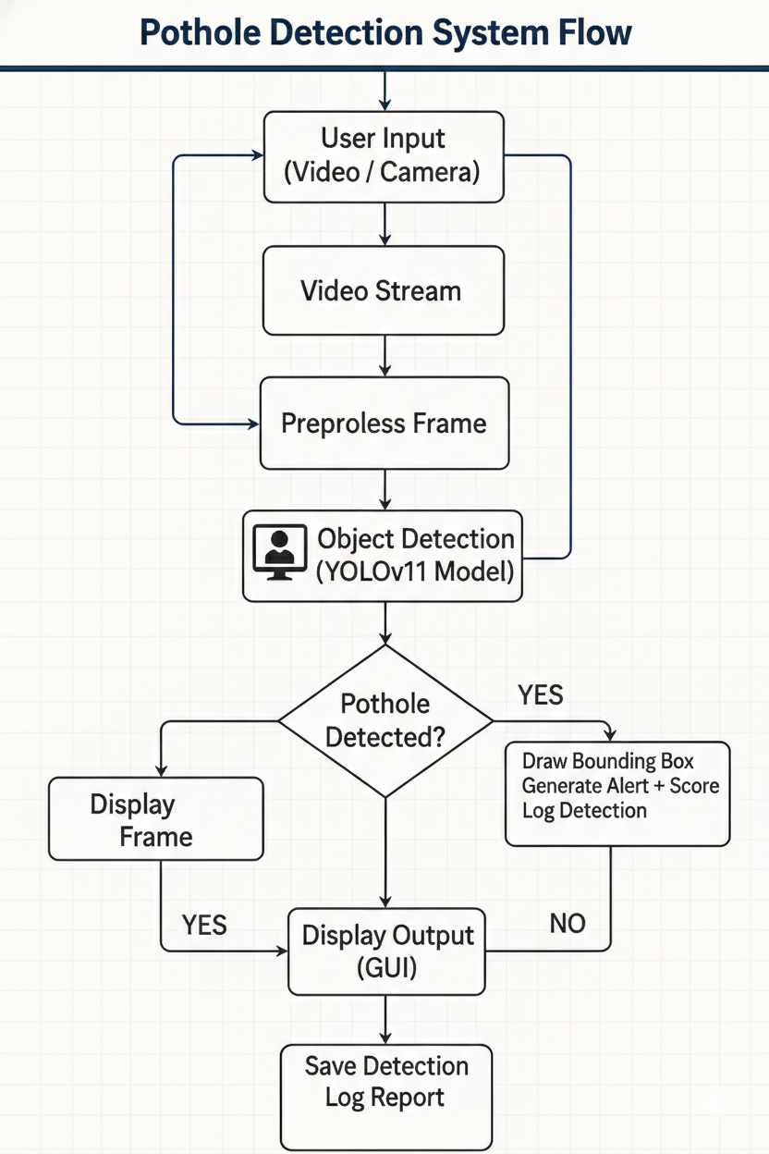

8. System Architecture
The system architecture consists of the following components:
- Input Module: Captures video from files or live camera feeds using OpenCV.
- Frame Extraction Module: Extracts individual frames from video streams for processing.
- Detection Module: Processes frames using the YOLOv11 model and identifies potholes.
- Alert Module: Generates visual and audio alerts when potholes are detected.
- GUI Module: Displays real-time video, bounding boxes, confidence scores, and alerts.
- Logging Module: Records detection events, timestamps, and metadata for analysis.

9. Implementation Tools
Component | Technology
Programming Language | Python 3.10+
Deep Learning Framework | PyTorch, Ultralytics YOLOv11
Computer Vision Library | OpenCV
GUI Framework | Tkinter / PyQt5
Dataset Management | Roboflow
Training Environment | Google Colab / Kaggle GPU
Annotation Tool | Roboflow
Logging Format | CSV / JSON
Table 9.1: Tools and Technologies Used

10. Expected Outcomes
The project is expected to deliver the following outcomes:
- A fully trained YOLOv11 model capable of detecting potholes with high accuracy
- A desktop application with a user-friendly interface for real-time pothole detection.
- Visual and text-based alerts for detected potholes with confidence scores.
- Automatic logging system generating detection reports for maintenance authorities.
- A final FYP report documenting all phases of the project, results, and future recommendations.
The system will demonstrate the practical application of deep learning in infrastructure monitoring and provide a foundation for future enhancements such as mobile deployment, cloud integration, and multi-class road damage detection.

11. Project Timeline

11.1 Timeline Table
Phase | Task | Weeks
1 | Background Study & Planning | Week 1–2
2 | Dataset Collection & Annotation | Week 3–4
3 | Model Training & Validation | Week 5–7
4 | Application Development | Week 8–10
5 | Alert System + GUI | Week 11–12
6 | Testing & Refinements | Week 13
7 | Documentation | Week 14
Table 11.1: Project Timeline (14 Weeks)

11.2 Gantt Chart

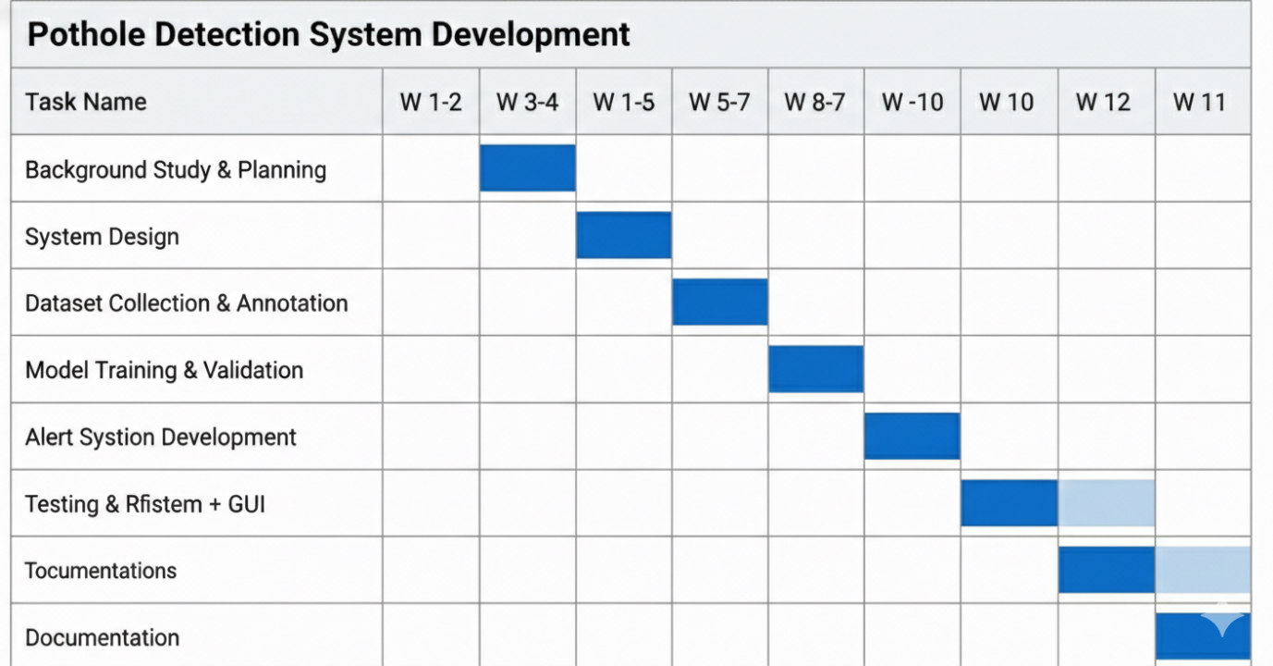
Table 11.2: Project Gantt chart (14 Weeks)
12. Conclusion
This project presents a comprehensive solution for automated pothole detection using YOLOv11, the latest advancement in real-time object detection. By leveraging deep learning and computer vision, the system enables continuous, accurate, and efficient monitoring of road conditions, addressing the limitations of traditional manual inspection methods.
The proposed system will detect potholes in real time from images or video feeds, generate instant alerts, and provide detailed logs for maintenance authorities. The desktop application will offer an intuitive interface, making the technology accessible to road engineers, municipal authorities, and infrastructure management teams.
Beyond immediate practical benefits, the project highlights the transformative potential of artificial intelligence in infrastructure monitoring and civil engineering. It demonstrates how modern AI models can be applied to real-world problems, improving public safety, reducing costs, and contributing to smarter, more sustainable cities.
The successful completion of this project will deliver a fully functional pothole detection system, comprehensive documentation, and a foundation for future research in automated road damage assessment and intelligent transportation systems.

13. References
- Redmon, J., & Farhadi, A. (2018). YOLOv3: An incremental improvement. arXiv preprint arXiv:1804.02767.
- Bochkovskiy, A., Wang, C. Y., & Liao, H. Y. M. (2020). YOLOv4: Optimal speed and accuracy of object detection. arXiv preprint arXiv:2004.10934.
- Ultralytics. (2025). YOLOv11 documentation. Retrieved from https://docs.ultralytics.com/models/yolo11/
- Jocher, G., Chaurasia, A., & Qiu, J. (2023). Ultralytics YOLOv8. Retrieved from https://github.com/ultralytics/ultralytics
- Bradski, G. (2000). The OpenCV library. Dr. Dobb's Journal of Software Tools.
- Roboflow. (n.d.). Pothole detection dataset. Retrieved from https://universe.roboflow.com/pothole-detection-v2/pothole-detection-v2
- Roboflow. (n.d.). Road damage detection dataset. Retrieved from https://universe.roboflow.com/road-damage-detection-2/road-damage-detection-2
- He, K., Zhang, X., Ren, S., & Sun, J. (2016). Deep residual learning for image recognition. Proceedings of the IEEE Conference on Computer Vision and Pattern Recognition (CVPR), 770–778.
- Lin, T. Y., Maire, M., Belongie, S., Hays, J., Perona, P., Ramanan, D., ... & Zitnick, C. L. (2014). Microsoft COCO: Common objects in context. European Conference on Computer Vision, 740–755.
- Maeda, H., Sekimoto, Y., Seto, T., Kashiyama, T., & Omata, H. (2018). Road damage detection and classification using deep neural networks with smartphone images. Computer-Aided Civil and Infrastructure Engineering, 33(12), 1127–1141.

